Deploy NodeJS to Heroku by using Heroku CLI

Adapted from [How to Deploy a Node.js App to Heroku ― Scotch.io](https://scotch.io/tutorials/how-to-deploy-a-node-js-app-to-heroku)

# Installation

Make sure you have Node.js and the Heroku CLI installed

[The Heroku CLI | Heroku Dev Center](https://devcenter.heroku.com/articles/heroku-cli)

# Logging Into Heroku

heroku login

# Creating a Simple Node Application

We skip this step by clonning a project on a public repo

git clone [git@github.com:scotch-io/heroku-node](mailto:git@github.com:scotch-io/heroku-node)

We'll just need a few files for this app. Go into your heroku-node folder and create the following files:

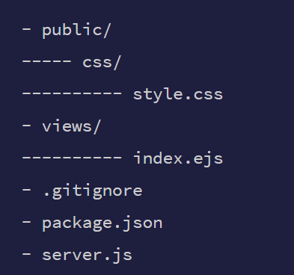

# Install required packages

npm install

# Testing Our Sample App locally

node server.js

# Deploying Your Node App to HeroK

heroku create

This will create a random name for our application, in this case, calm-reaches-6216. That isn't really ideal so let's rename that to heroku-node

heroku apps:rename heroku-node --app calm-reaches-6216

# Deploying Code

git push heroku master

# View Our Application in Browser

heroku open